SIMATS ENGINEERING (SAVEETHA SCHOOL OF ENGINEERING)
Course Code & Title: | ECA5604 -5G/6G COMMUNICATION | Course Faculty: | Dr.K.Sathish
Student Name: | Velamuri Bhanodhay | Reg. No.: | 192412330
Dept / Batch: | BE.ECE / 2024 | Date: | 19/8/2026
Lab Observation

Experiment 11 : Implementation of IoT-based Smart Agriculture using MATLAB

Objective 1: To monitor the Soil Moisture (%) level in agricultural fields using IoT-based sensing
simulation in MATLAB.

Matlab Code:

clc;clear;close all
t=1:10; M=[30 35 28 25 20 18 22 30 40 45]; T=40;
subplot(211)
plot(t,M,'-o','LineWidth',2);grid on
title('Soil Moisture Monitoring in IoT Smart Agriculture')
xlabel('Time (Hours)'),ylabel('Soil Moisture (%)');hold on
yline(T,'r--','Threshold')
subplot(212)
stem(t,M>=T,'filled','LineWidth',2);grid on
title('Soil Condition Status (1=Wet, 0=Dry)'),xlabel('Time (Hours)'),ylabel('Status')

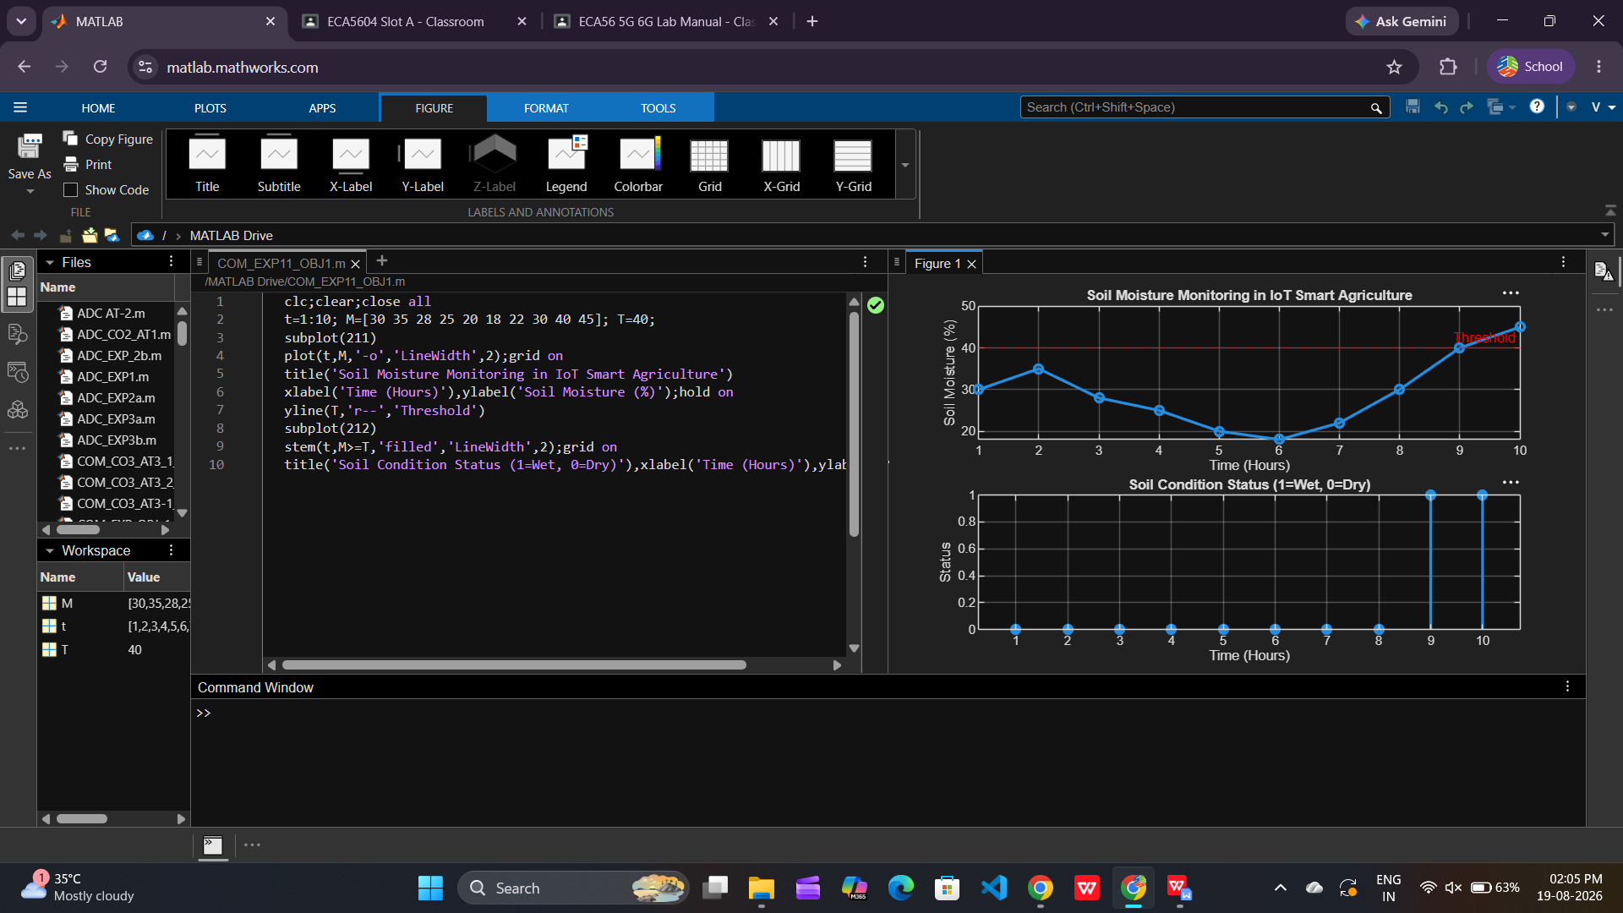

Objective 2: To control and display the Water Pump Status (ON/OFF) based on threshold soil
moisture conditions.

Matlab Code:

clc;clear;close all
t=1:10; M=[30 35 28 25 20 18 22 30 40 45]; T=40;
P=M<T;
subplot(211)
plot(t,M,'-o','LineWidth',2);grid on
title('Soil Moisture vs Pump Control')
xlabel('Time (Hours)'),ylabel('Soil Moisture (%)');hold on
yline(T,'r--','Threshold')
subplot(212)
stem(t,P,'filled','LineWidth',2);grid on
title('Water Pump Status (1=ON, 0=OFF)'),xlabel('Time (Hours)'),ylabel('Pump Status')

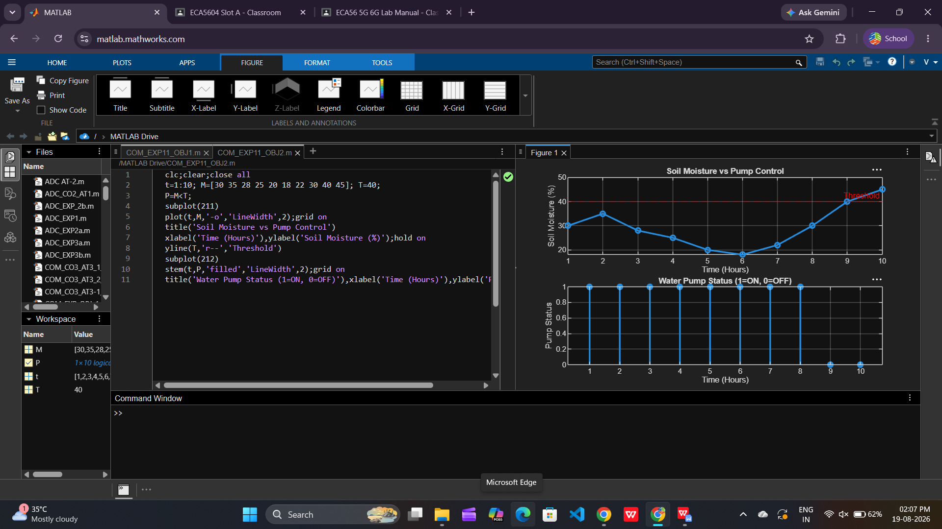

Objective 3: To evaluate the Irrigation Efficiency (%) by analyzing water usage effectiveness and
moisture maintenance level.

Matlab Code:

clc;clear;close all
t=1:10; M=[30 35 28 25 20 18 22 30 40 45]; T=40;
E=min(M/T*100,100);
subplot(211)
plot(t,M,'-o','LineWidth',2);grid on
title('Soil Moisture Variation')
xlabel('Time (Hours)'),ylabel('Soil Moisture (%)');hold on
yline(T,'r--','Threshold')
subplot(212)
plot(t,E,'-s','LineWidth',2);grid on
title('Irrigation Efficiency (%) in Smart Agriculture'),xlabel('Time (Hours)'),ylabel('Efficiency (%)')

